Annual Derry Township Agricultural Fair
BASS TOURNAMENT
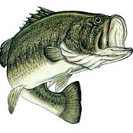

Saturday, July 16, 2022
7:00 AM to 11:00 AM
Open to all Ages
Entry Fee - $25.00
(Limited to the first 50 entries)

PRIZES: 1st - $250.00, 2nd - $150.00, 3rd – 75.00, 4th - $50.00, 5th - $25.00
(A minimum of 25 entries must be made, otherwise only payout on 1st place.)

Registration on entry day will begin at 6:30 AM or register by mail on the entry form below. Mail completed entry form and registration fee of $25.00 to:

Derry Twp. Ag Fair
P.O. Box 261
New Derry, PA 15671

Questions regarding the tournament may be directed to Dave Durika 724-304-1853

Name: ____________________________________________________
Mailing address: ____________________________________________
City/State: _________________________________________________
Phone #: ________________________________
This form may be duplicated as needed.

